Project Report Template

Political Juggernauts: A Quantitative Analysis of Candidates in

the 2019 Lok Sabha Election

***1.INTRODUCTION:***

* ***Overview:***

The Lok Sabha is composed of representatives of people chosen by direct Election on the basis of Universal Adult Suffrage. The Constitution of India allows for a maximum of 550 members in the House, with 530 members representing the States and 20 representing the Union Territories. The 17th Lok Sabha was formed by the members elected in the 2019 Indian general election. Elections, all across India, were conducted in seven phases from 11 April 2019 to 19 May 2019 by the Election Commission of India. The Bharatiya Janata Party received 37.36% of the vote, the highest vote share by a political party since the 1989 general election, and won 303 seats, further increasing its substantial majority. In addition, the BJP-led National Democratic Alliance (NDA) won 353 seats.

* ***Purpose:***

1. To understand he trends in candidate selection by political parties in India.

2. To identify the key factors that influence candidate success in the 2019 Lok sabha elections.

3. To compare and contrast the performance of different types of candidates, suh as incumbents, women, and candidates from minority groups.

4. To assess the impact of various electoral reforms on candidate selection and performance.

5. A political party could use the project to identify promising candidates for future elections.

***2.PROBLEM DEFINITION & DESIGN THINKING:***

* ***Emptahy map***

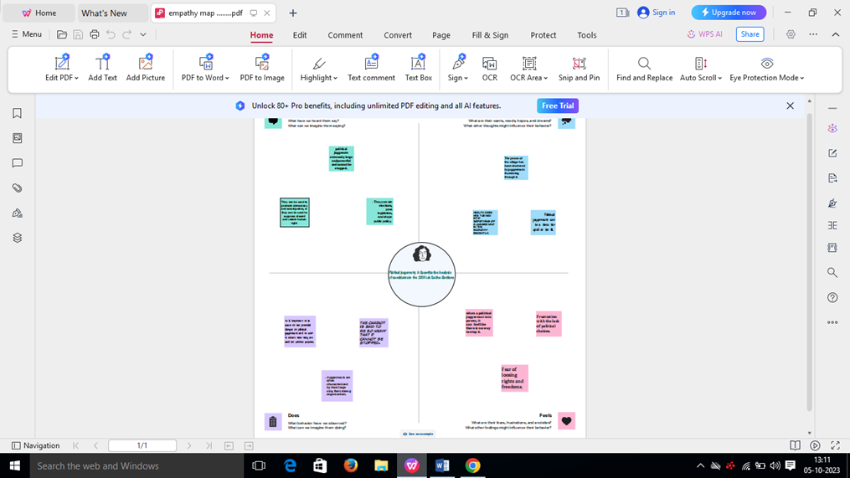

* 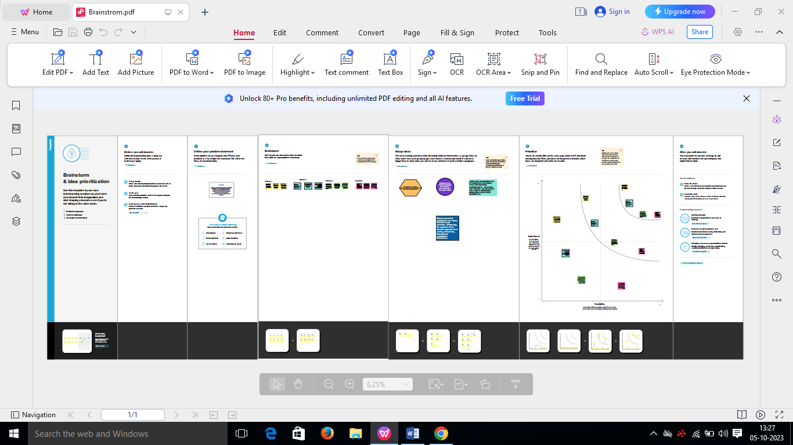***Ideation & Brainstorming Map:***

***3. RESULT:***

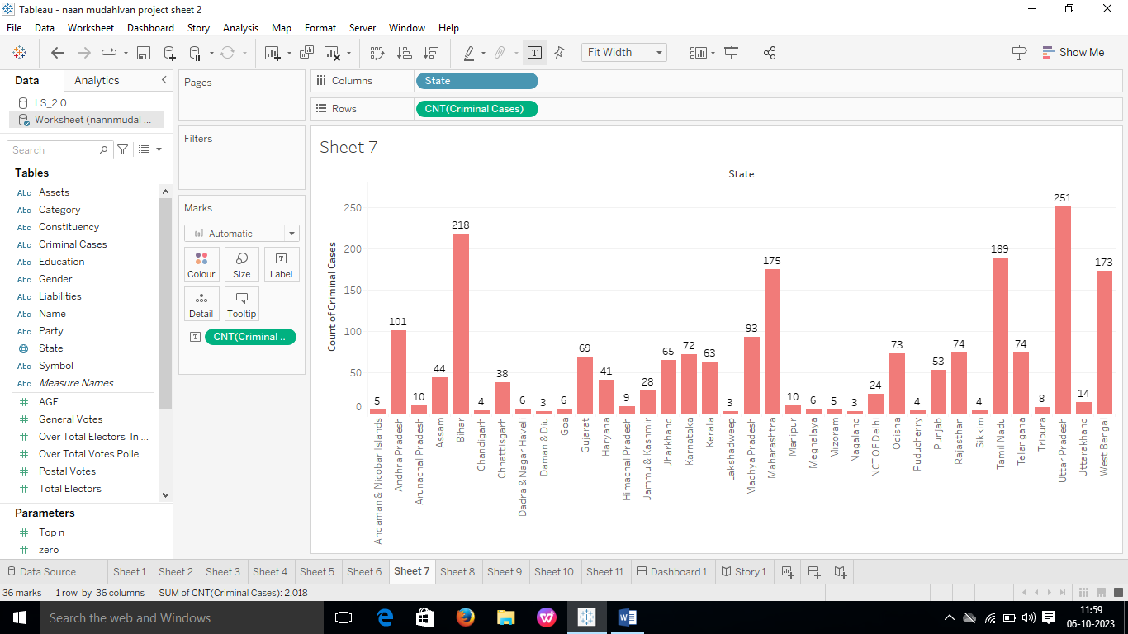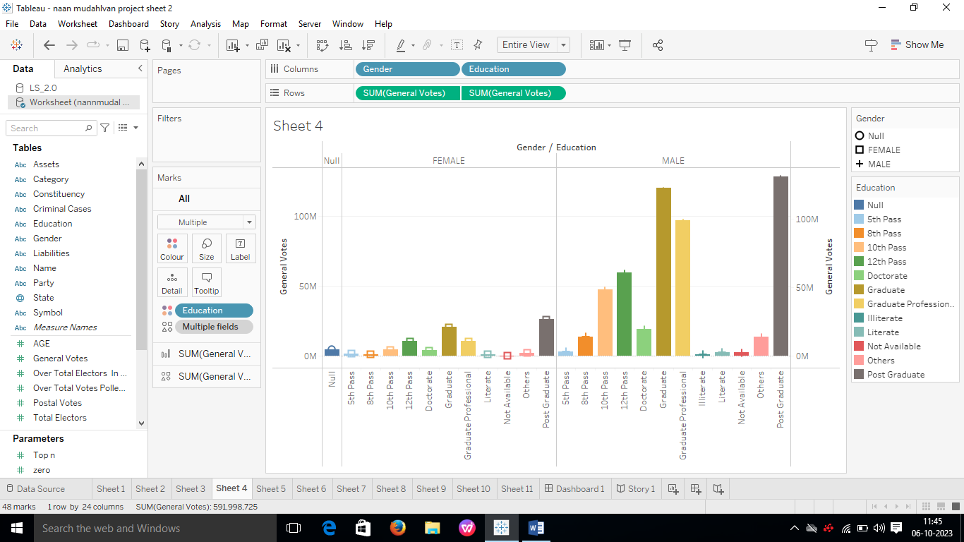

# 

# 

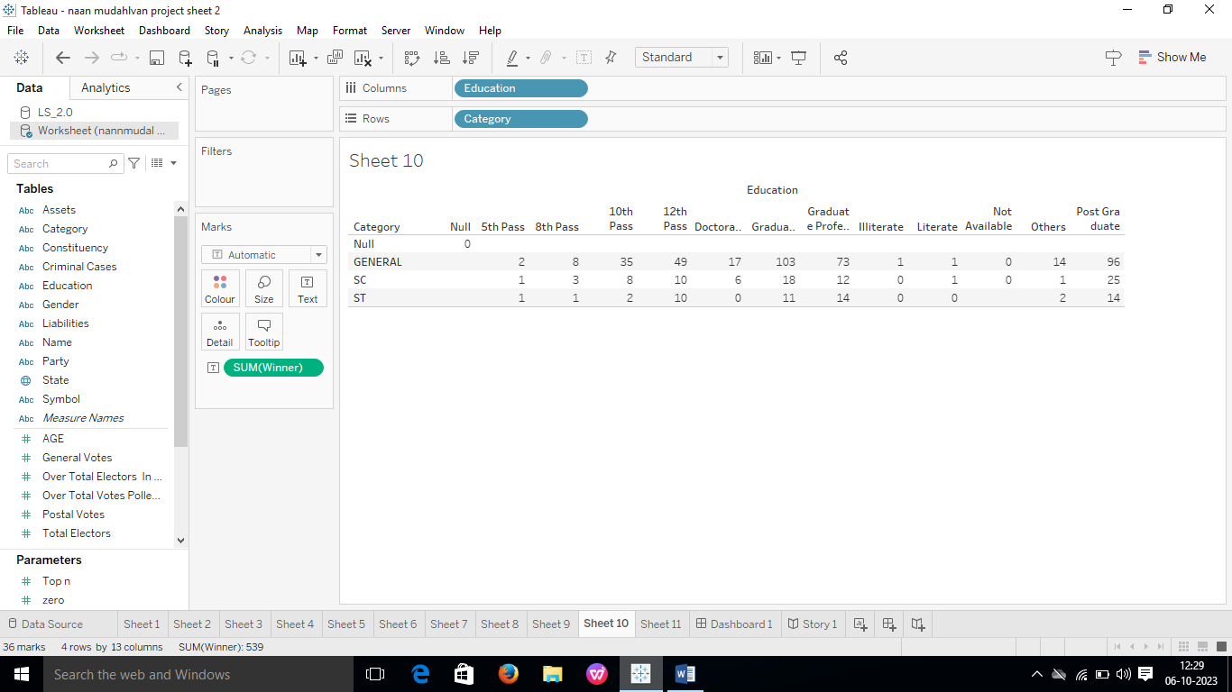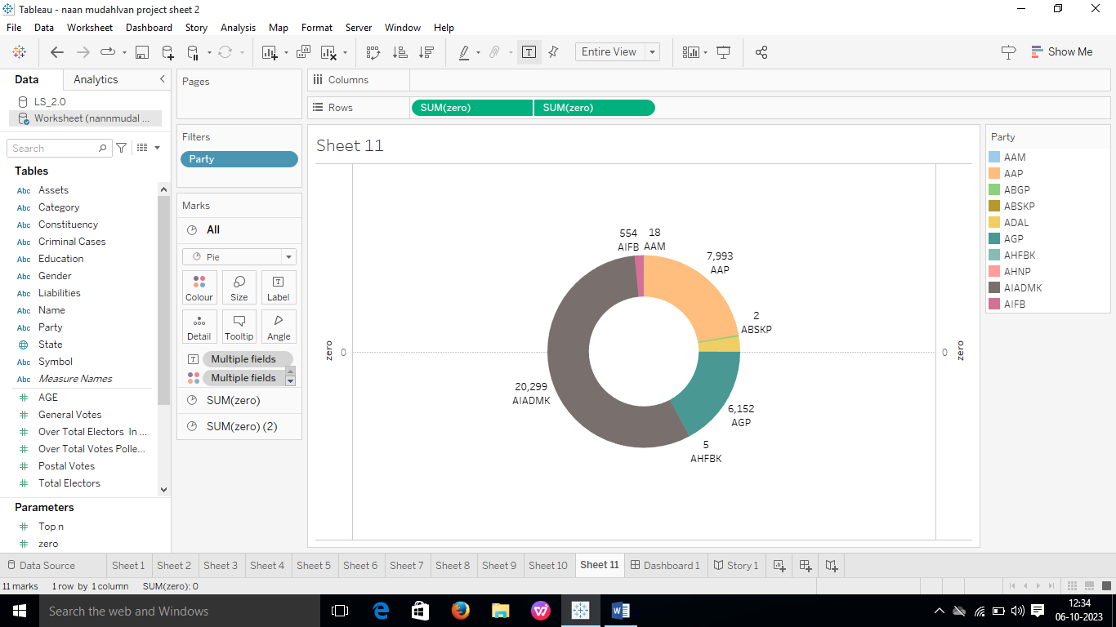

***Story book:***

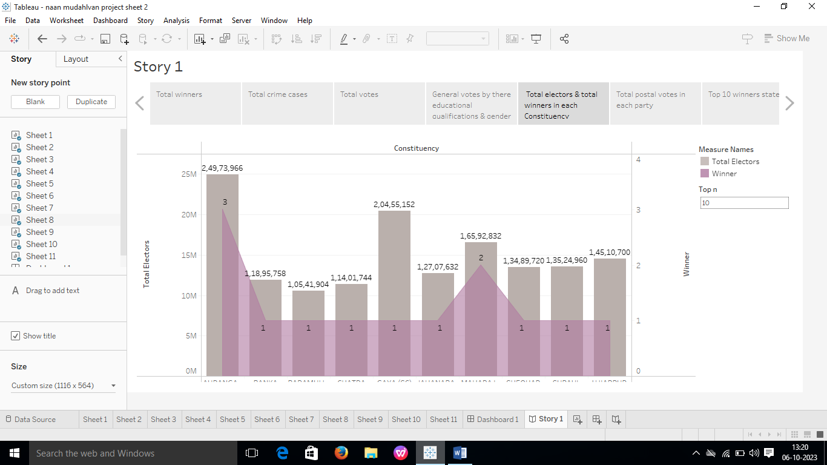

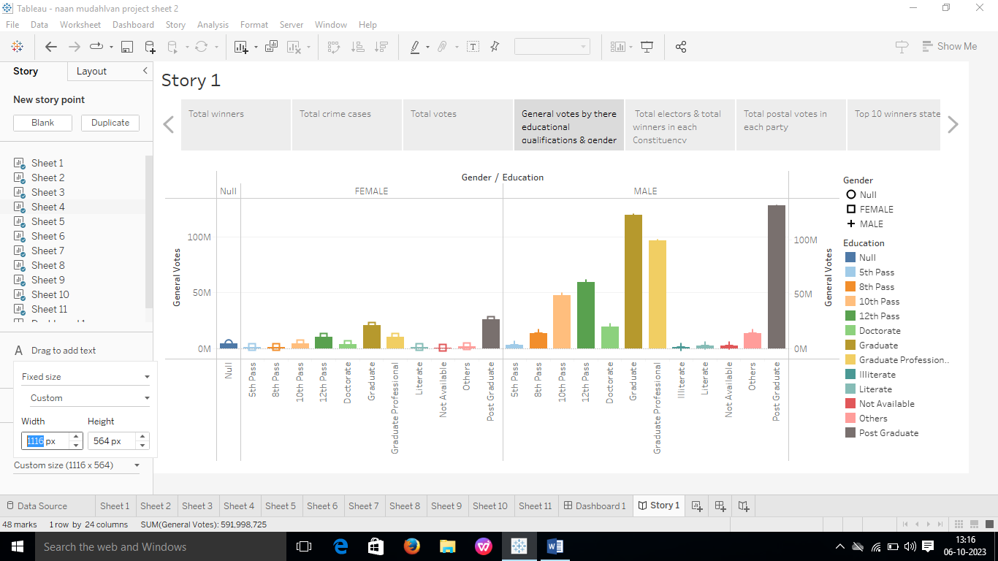

***Story book:***

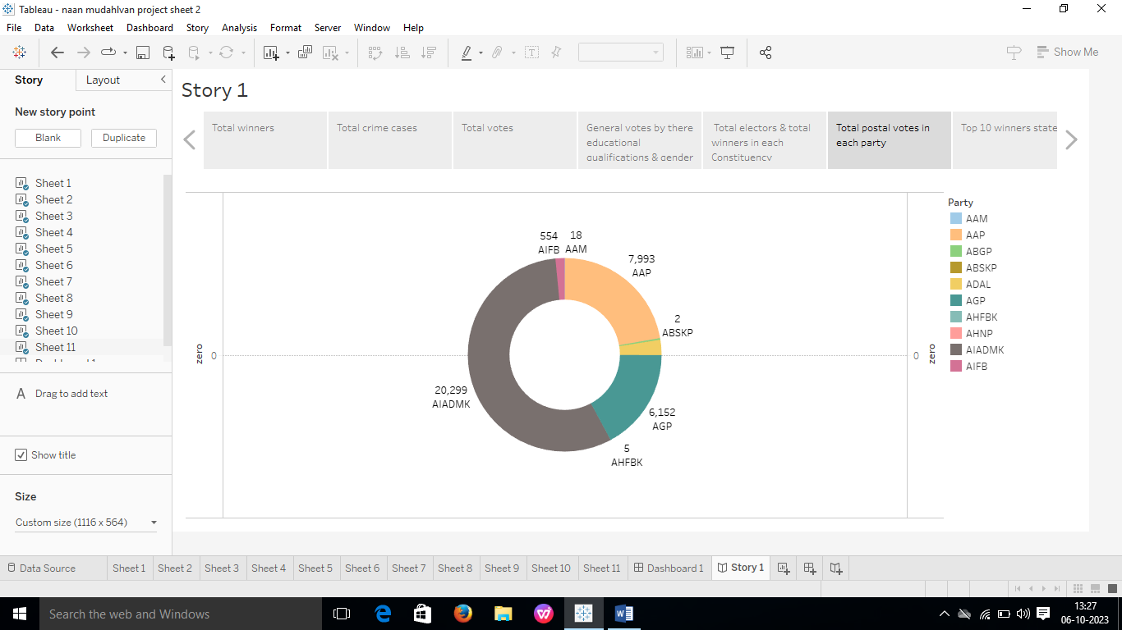

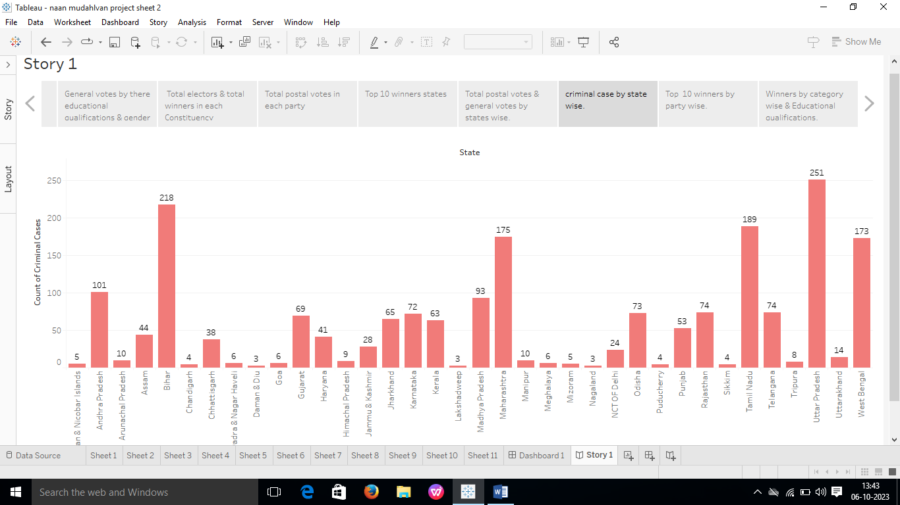***Story Book:***

***4. ADVANTAGES AND DISADVANTAGES OF PROJECT:***

* **Advantages:**
* It can identify patterns and trends that may not be immediately apparent to the human eye.
* It can help to quantify the impact of various factors on electoral success.
* It can provide insights into the changing nature of Indian politics.
* **Disadvantages:**
* It can be difficult to collect and analyse high-quality data.
* Quantitative analysis can be complex and difficult to interpret.
* It is important to be aware of the limitations of quantitative analysis, such as the fact that it cannot capture all of the factors that it cannot capture all of the factors that electoral outcomes.

***Story Book:***

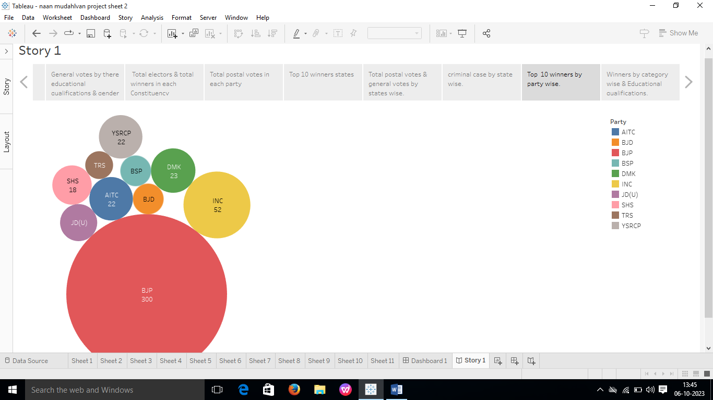

***Story Book:***

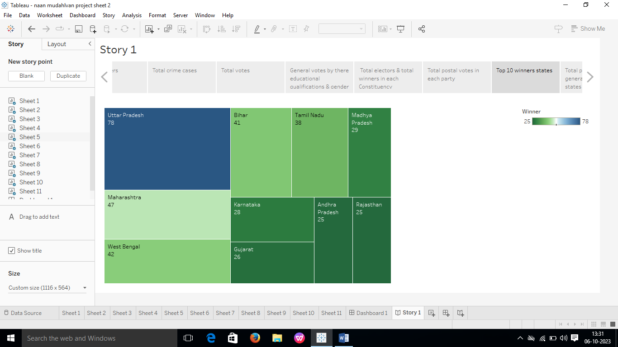

***Story Book:***

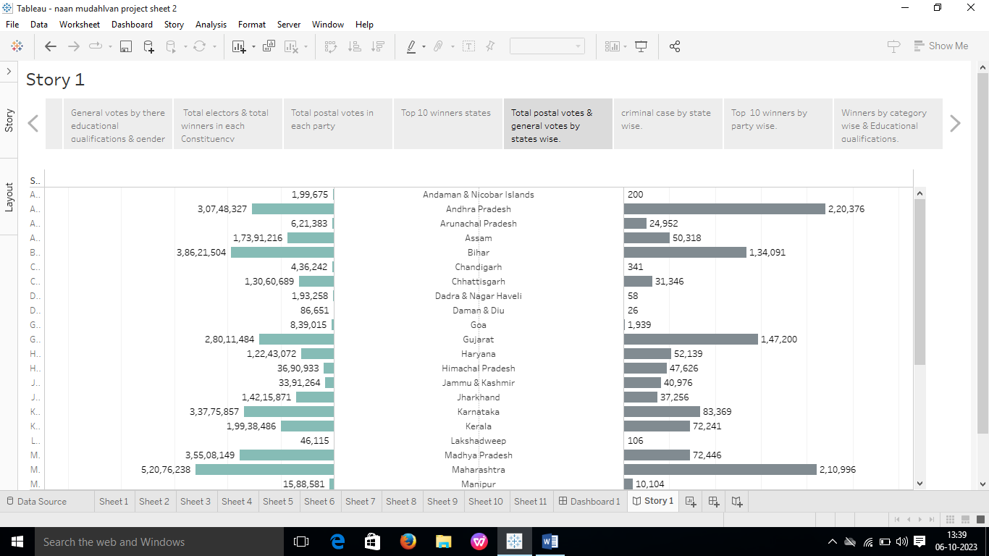

***Story Book:***

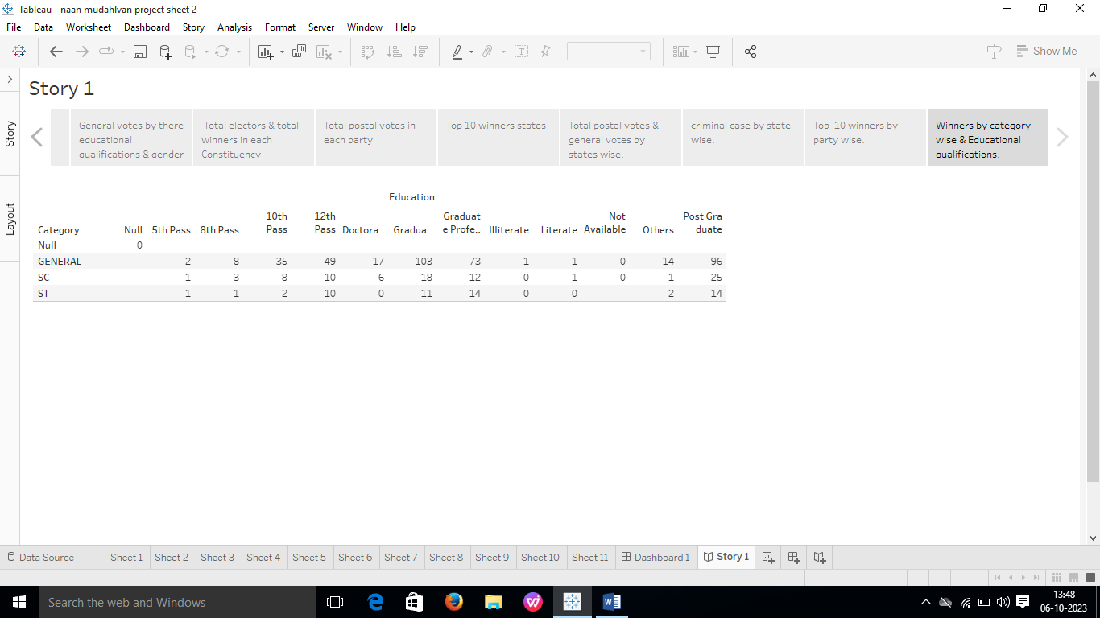

***5. APPLICATIONS:***

1. Predicting election outcomes: The paper's analysis of the factors that contribute to electoral success can be used to develop models that predict election outcomes. This information can be useful for political parties, candidates, and voters in planning and preparing for elections.
2. Identifying political talent: The paper's findings on the characteristics of successful candidates can be used to identify and groom potential political leaders. This could help to improve the quality of political representation in India.
3. Designing electoral reforms: The paper's analysis of the challenges faced by marginalized groups in elections can be used to design electoral reforms that make the system more inclusive and representative.

***6. CONCULTION:***

The paper "Political juggernauts: A Quantitative Analysis of candidates in the 2019 Lok Sabha Elections" is a quantitative analysis of the factors that contribute to electoral success in India. The paper uses data on over 8,000 candidates who contested the 2019 Lok Sabha elections to examine the relationships between various factors, such as candidate profile, campaign spending, and electoral performance.

***7. FUTURE SCOPE:***

* *Data Analysis and Prediction*: Utilize data analytics and machine learning to predict political trends, election outcomes, or public opinion shifts. This could be valuable for political campaigns and strategists.
* *Policy Analysis*: Develop tools to analyze and compare political parties' policy positions, helping voters make informed decisions.
* *Political Engagement*: Create platforms or apps to increase political engagement, voter registration, and participation in elections.
* *Political Education*: Develop educational resources and content to inform the public about political processes, governance, and civic responsibilities.

Submitted by,

* **Andreya Mani**
* **Anand**
* **Afra Fathima**
* **Abisha**